RESTFUL API CONTRIBUTER


Name | Role | Cognizant ID
Prakhar Jaiswal | Frontend, Backend | 768953
Harmeet Singh | Frontend, Backend | 768965
Jatin Chhabra | Frontend, Backend | 769618

Table of Contents
1 Introduction 5
1.1 About this document 5
1.1.1 Purpose & Scope of the document 5
1.1.2 Intended Audience 5
1.2 Application Programming Interface(API) 5
1.2.1 Advantages of API 6
1.3 Types of API 6
1.3.1 Open API 7
1.3.2 Partner APIs 9
1.3.3 Internal APIs 9
1.3.4 Data and Service APIs 10
1.3.5 Web Service APIs 11
2.1 About REST 16
2.2 RESTful Web Services 18
2.3 Guidelines to design a clean RESTFul API 19
2.3.1 Use Nouns but no verbs 19
2.3.2 GET method and query parameters should not alter the state 19
2.3.3 Use Plural nouns 19
2.3.4 Use sub-resources for relations 20
2.3.5 Use HTTP headers for serializations formats 20
2.3.6 Provide filtering, sorting, field selection and paging for selections 20
2.3.7 Version our API 21
2.4 Architectural Constraints 21
2.4.1 Uniform Interface 22
2.4.2 Client-Server 22
2.4.3 Stateless Server 23
2.4.4 Cacheable 24
2.4.5 Layered System 25
2.4.6 Code on Demand 26
2.5 How RESTful APIs work 27
2.6 REST VS SOAP 28
2.7 Optimistic locking 29
3 Tools & Frameworks Used 30
3.1 Visual Studio Code 30
3.1.1 Visual Studio Code in action 31
3.2 Angular 31
3.2.1 Advantages of Angular 32
3.2.2 Installation of Angular 33
3.2.3 TypeScript 37
3.2.4 ECMA Script 38
3.3 Python 39
3.3.1 Python Features 40
3.3.2 Python Installation 40
3.4 Flask 42
4 Implementation 44
4.1 Creating Server 44
4.2 Creating Client Side 45

Introduction

1.1 About this document

Purpose & Scope of the document
The purpose of the software requirements document is to systematically capture requirements for the project and the system “RESTFUL API CONTRIBUTER” to be developed. Functional requirements of this system are captured in this document. It also serves as the input for the project scoping.
The scope of this document is limited to addressing the requirements from a user, quality, and non-functional perspective. It is recommended that design aspects are not added in this document

Intended Audience
Project Team

Application Programming Interface(API)
API, for application programming interface, is one of those acronyms that is used everywhere from command-line tools to enterprise Java code to Ruby on Rails web apps. Unless you write every single line of code from scratch, you’re going to be interacting with external software components, each with its own API. Even if you do write something entirely from scratch, a well-designed software application will have internal APIs to help organize code and make components more reusable.
Diving a little deeper, an API is a specification of possible interactions with a software component. For example, if a car was a software component, its API would include information about the ability to accelerate, brake, and turn on the radio. It would also include information about how to accelerate: Put your foot on the gas pedal and push. The “what” and “how” information come together in the API definition, which is abstract and separate from the car itself.

Advantages of API
- Automation: with APIs, computers rather than people can manage the work. Through APIs, agencies can update work flows to make them quicker and more productive.

- Application: because APIs can access the app components, the delivery of services and information is more flexible.
- More scope: with an API an application layer can be created which can be used to distribute information and services to new audiences which can be personalized to create custom user experiences.
- Efficiency: when access is provided to an API, the content generated can be published automatically and is available for every channel. It allows it to be shared and distributed more easily.
- Integration: APIs allow content to be embedded from any site or application more easily. This guarantees more fluid information delivery and an integrated user experience.
- Personalization: through APIs any user or company can customize the content and services that they use the most.

Types of API
Based on how systems or software interact with one another in building the application architecture, there are several APIs available for web service, hardware, operating systems, data structures, programmatic interfaces etc. Some of the standard API class libraries and frameworks are specifically helpful in performing specific actions and exchange of information. For instance, by including or integrating a JavaScript Google Maps API in the code, developers can add the feature of interactive Google Maps to an application or a web page. Another example is a YouTube Data API. Using this API, developers can include YouTube functionality to the site to retrieve and manipulate resources like videos, playlists, and channels.

Open API
An open API, also known as a public API, is an application programming interface that allows the owner of a network-accessible service to give universal access to consumers of that service, such as developers.
An API is a software intermediary that makes it possible for application programs to interact with each other and share data. It's often an implementation of REST that exposes a specific service or software functionality while protecting the rest of the application.
Open APIs are published on the internet and shared freely. A startup software company, for example, might publish a series of APIs to encourage third-party developers in vertical industries to be innovative and figure out new ways to use the startup's software product. In theory, it's a win-win business arrangement.

Benefits of API :-
Using an open API, a third-party developer can make money by licensing a new program, a mashup with advanced functionalities or an innovative use of the service being accessed that provides users value in ways the originator of the service had never envisioned.
Meanwhile, the open API's publisher gets to expand its user base without having to spend any money to develop niche industry software -- and it still gets to keep its source code proprietary.

Drawbacks of Open APIs
Using an open API, a third-party developer can make money by licensing a new program, a mashup with advanced functionalities or an innovative use of the service being accessed that provides users value in ways the originator of the service had never envisioned.
Meanwhile, the open API's publisher gets to expand its user base without having to spend any money to develop niche industry software -- and it still gets to keep its source code proprietary.

Open API management
Once an API is made public, it is difficult for an organization to control who uses the API and how they use it. As a result, API management must be taken seriously; otherwise, issues can arise in terms of customer satisfaction.
For example, organizations must be careful when they decommission older APIs, change the syntax of a RESTful method call, alter the structure of an XML or JSON payload, or retire a given piece of functionality, as the control that might exist within an organization over how an API is used and who is using it simply does not apply to the public at large.
When changes to an API are not managed properly, end users become disaffected, and that can hurt the reputation of the organization providing the public API.

Examples of open APIs
There are many uses of open APIs. One of the most common areas for both the availability and consumption of open APIs is in social media.
For example, Facebook provides an open API that allows third-party tools to create photo albums or post to a user's news feed. In fact, Facebook has a built-in function that allows the items you add publicly to your news feed to also be posted to your Twitter feed. In that case, the Facebook application is actually using the open API from Twitter to make that interaction happen.
Many software products also come with an open API, allowing programmatic access to the data they contain. For example, Microsoft's SharePoint collaboration platform provides a REST API that allows access to the FAST Search service. When queried using the open API, authenticated users can query the SharePoint platform for published documents based on date, title, ID and a variety of other attributes.

Partner APIs
Partner APIs are APIs exposed by/to the strategic business partners. They are not available publicly and need specific entitlement to access them.

Both Open APIs and partner APIs are the tip of the iceberg because they are the most visible ones and are used to communicate beyond the boundaries of the company. They are usually exposed into a public API developer portal that developers can access in a self-service mode. While open APIs are completely open, there is an on-boarding process with a specific validation workflow to get access to partner APIs.

Internal APIs
- Internal APIs – aka private APIs – are usually less known and only exposed by internal systems. They are also often not meant for consumption outside of the company but for being used across different internal development teams for better productivity and reuse of services. A good governance process consists in exposing them into an internal API developer portal that connects to the internal IAM systems to authenticate and authorize users to access the right set of APIs.

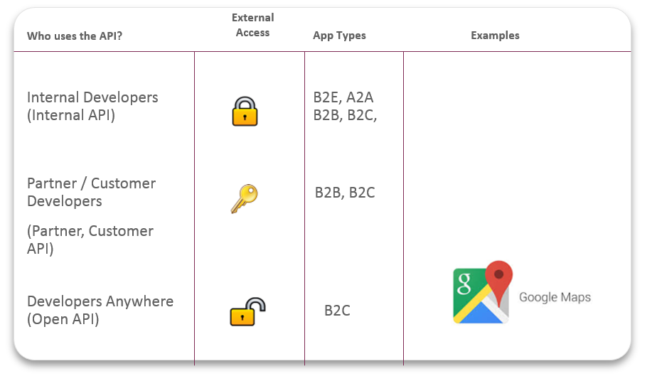
Fig No1. Types of APIs

Data and Service APIs
Beyond the difference between internal, partner and open APIs, we should mention another approach to categorize APIs:
- Data APIs provide CRUD access to underlying data sets. These APIs are needed to serve some fundamental data coming from SaaS application – with help from SaaS connectors – or internal data stores.
- Internal service APIs consist in exposing internal services – often legacy SOAP Web Services – reflecting parts of internal processes or some complex actions – into REST APIs.
- External service APIs are 3rd party services than can be easily embedded into the existing services of the company to bring additional value. – e.g. an external email service like Send grid.
- Composite APIs combine multiple data or service APIs. They are built using API orchestration capabilities of an API creation tool.
- User experience APIs leverage composite APIs to help app developers provide the right experience for each specific device (desktop, mobile, tablet, VPA, IOT).

Web Service APIs
Among several API types, web APIs are widely used to integrate software or a service in a website or app through World Wide Web. That means through HTTP protocol the exchange of data or information occurs between desktop, mobile and web applications. Depending on the data transfer formats used in request-response messaging, web APIs are classified as SOAP (Simple Object Access Protocol), RPC (Remote Procedure Call), and REST (Representational State Transfer). These are the different protocols through which exchange of information takes place over web. The most common data formats used to define the response / request messages are XML, JSON, HTML or binary files for documents, videos and images.
The web APIs are further divided into client and server side based on how they extend their functionality in web browser. Client side APIs are broadly used for manipulating different

aspects of browser whereas server side APIs are meant for executing functionality on a server before the data is sent to browser. When a request is made to an API, the result will be in the form of response invoking an action. But there are some special server side APIs called web hooks that act as user-defined HTTP callbacks to invoke a behavior or event. By configuring an event in one website, an action can be automatically invoked in the other. That means whenever the condition is met in the source site, web hooks acknowledge the event, and triggers the action on the url specified in the form of HTTP request.
Most often-used types of web service:
- SOAP
- XML-RPC
- JSON-RPC
- REST

SOAP
SOAP is a standard communication protocol system that permits processes using different operating systems like Linux and Windows to communicate via HTTP and its

XML. SOAP based APIs are designed to create, recover, update and delete records like accounts, passwords, leads, and custom objects.
These offers over twenty different kinds of calls that make it easy for the API developers to maintain their accounts, perform accurate searches and much more. These can then be used with all those languages that support web services.
SOAP APIs take the advantages of making web based protocols such as HTTP and its XML that are already operating the all operating systems that are why its developers can easily manipulate web services and get responses without caring about language and platforms at all.

SOAP Advantages and Disadvantages:-

SOAP is an integral part of the service-oriented architecture (SOA) and the services specifications associated with SOA. Because it allows the sender to create a message route based on the logical services that have to be applied to the message on the way to its destination, it lends itself to providing secure and compliant connections, controlling access, offering reliable delivery and failure recovery, and supporting dynamic service discovery. SOA without SOAP is difficult to imagine.
SOAP’s messages are defined at a high level in XML, but most SOAP applications use Web Services Definition Language (WSDL), which is authored in XML. The XML structure of SOAP makes it handy for applications that expect their information to be provided in XML form, and the fact that SOAP can ride on a variety of network protocols, including HTTP, means it’s easily passed through firewalls, where other protocols might require special accommodation.
The data structure of SOAP is based on XML, which is similar in many ways to the HTML used to define web pages. Like HTML, XLM is largely human-readable, which makes it fairly easy to understand a SOAP message, but also makes the messages relatively large in comparison to the Common Object Request Broker Architecture (CORBA) and its Remote Procedure Call (RPC) protocol that will accommodate binary data.

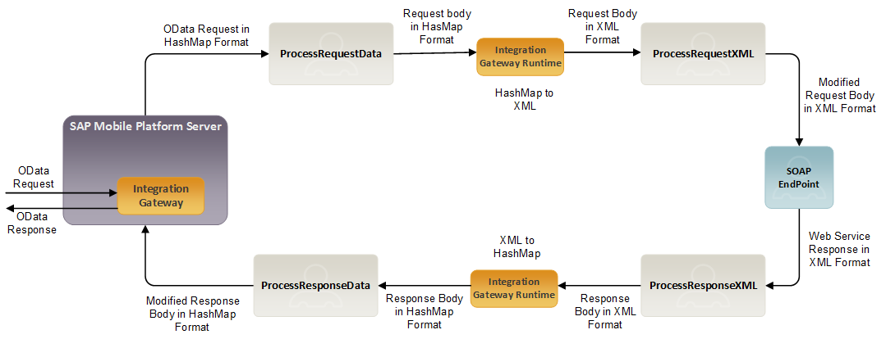
Fig No 2. SOAP Flow Diagram

XML – RPC
RPC stands for Remote Procedure Call. As its name indicates, it is a mechanism to call a procedure or a function available on a remote computer. RPC is a much older technology than the Web. Effectively, RPC gives developers a mechanism for defining interfaces that can be called over a network. These interfaces can be as simple as a single function call or as complex as a large API.
XML-RPC is among the simplest and most foolproof web service approaches that makes it easy for computers to call procedures on other computers.
- XML-RPC permits programs to make function or procedure calls across a network.
- XML-RPC uses the HTTP protocol to pass information from a client computer to a server computer.
- XML-RPC uses a small XML vocabulary to describe the nature of requests and responses.
- XML-RPC client specifies a procedure name and parameters in the XML request, and the server returns either a fault or a response in the XML response.
XML-RPC consists of three relatively small parts:
- XML-RPC data model: A set of types for use in passing parameters, return values, and faults (error messages).

- XML-RPC request structures: An HTTP POST request containing method and parameter information.
- XML-RPC response structures: An HTTP response that contains return values or fault information.
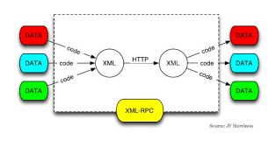
Fig No 3. XML – RPC Procedure

JSON – RPC
JSON-RPC is a remote procedure call protocol encoded in JSON. It is a very simple protocol (and very similar to XML-RPC), defining only a few data types and commands. JSON-RPC allows for notifications (data sent to the server that does not require a response) and for multiple calls to be sent to the server which may be answered out of order.

Usage
JSON-RPC works by sending a request to a server implementing this protocol. The client in that case is typically software intending to call a single method of a remote system. Multiple input parameters can be passed to the remote method as an array or object, whereas the method itself can return multiple output data as well. (This depends on the implemented version.)
All transfer types are single objects, serialized using JSON.^{[1]} A request is a call to a specific method provided by a remote system. It must contain three certain properties:
- method - A String with the name of the method to be invoked.
- params - An Object or Array of values to be passed as parameters to the defined method.
- id - A value of any type used to match the response with the request that it is replying to.
The receiver of the request must reply with a valid response to all received requests. A response must contain the properties mentioned below.
- result - The data returned by the invoked method. If an error occurred while invoking the method, this value must be null.
- error - A specified error code if there was an error invoking the method, otherwise null.
- id - The id of the request it is responding to.

REST
Representational State Transfer (REST) is a software architectural style that defines a set of constraints to be used for creating Web services. Web services that conform to the REST architectural style, termed RESTful Web services (RWS), provide interoperability between computer systems on the Internet. RESTful Web services allow the requesting systems to access and manipulate textual representations of Web resources by using a uniform and predefined set of stateless operations. Other kinds of Web services, such as SOAP Web services, expose their own arbitrary sets of operations.
By using a stateless protocol and standard operations, RESTful systems aim for fast performance, reliability, and the ability to grow, by re-using components that can be managed and updated without affecting the system as a whole, even while it is running.

REST API

About REST
A RESTful API is an application program interface (API) that uses HTTP requests to GET, PUT, POST and DELETE data.
A RESTful API -- also referred to as a RESTful web service -- is based on representational state transfer (REST) technology, an architectural style and approach to communications often used in web services development.
REST technology is generally preferred to the more robust Simple Object Access Protocol (SOAP) technology because REST leverages less bandwidth, making it more suitable for internet usage. An API for a website is code that allows two software programs to communicate with each another. The API spells out the proper way for a developer to write a program requesting services from an operating system or other application.
The REST used by browsers can be thought of as the language of the internet. With cloud use on the rise, APIs are emerging to expose web services. REST is a logical choice for building APIs that allow users to connect and interact with cloud services. RESTful APIs are used by such sites as Amazon, Google, LinkedIn and Twitter.

HTTP Methods -
The following HTTP methods are most commonly used in a REST based architecture.
• GET - Retrieves one or more resources identified by the request URI and it can cache the information receive. Provides a read only access to a resource.
• PUT - Used to create a new resource or Update an existing resource on the server specified by the request URI.
• DELETE - Delete an existing resource on the server specified by the request URI. It always returns an appropriate HTTP status for every request.
• POST - Create a resource from the submission of a request and response is not cacheable in this case. This method is unsafe if no security is applied to the endpoint as it would allow anyone to create a random resource by submission. Used to update an existing resource or create a new resource.
• OPTIONS - Used to get the supported operations on a resource
GET, PUT, DELETE methods are also known as Idempotent methods. Applying an operation once or applying it multiple times has the same effect. Example: Delete any resource from the server and it succeeds with 200 OK and then try again to delete that resource than it will display an error message 410.
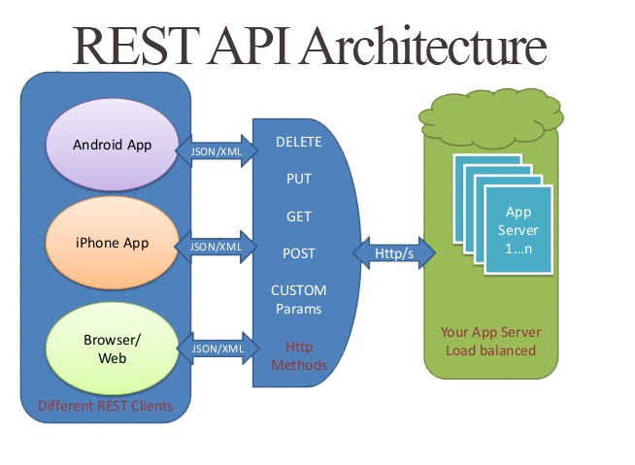
Fig No 4 - REST API Architecture

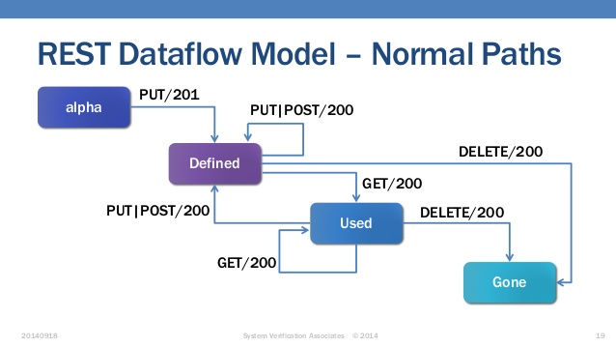

Fig No 5. REST Dataflow Model

RESTful Web Services
A web service is a collection of open protocols and standards used for exchanging data between applications or systems. Software applications written in various programming languages and running on various platforms can use web services to exchange data over computer networks like the Internet in a manner similar to inter-process communication on a single computer. This interoperability (e.g., between Java and Python, or Windows and Linux applications) is due to the use of open standards. Web services based on REST Architecture are known as RESTful Web Services. These web services use HTTP methods to implement the concept of REST architecture. A RESTful web service usually defines a URI (Uniform Resource Identifier), which is a service that provides resource representation such as JSON and a set of HTTP Methods.

Sr. No | HTTP Method | URI | Operation | Operation Type
1 | GET | /UserService/users | Get list of users | Read Only
2 | GET | /UserService/users/1 | Get User with Id 1 | Read Only
3 | PUT | /UserService/users/2 | Insert User with Id 2 | Idempotent
4 | POST | /UserService/users/2 | Insert User with Id 2 | N/A
5 | DELETE | /UserService/users/1 | Delete User with Id 1 | Idempotent
6 | OPTIONS | /UserService/users | List the supported operations in web service | Read Only

Guidelines to design a clean RESTFul API

Use Nouns but no verbs
For an easy understanding use this structure for every resource:

esource | GET  read | POST  create | PUT  update | DELETE
/cars | Returns a list of cars | Create a new car | Bulk update of cars | Delete all cars
/cars/711 | Returns a specific car | Method not allowed (405) | Updates a specific car | Deletes a specific car

GET method and query parameters should not alter the state
Use PUT,POST and DELETE methods instead of the GET method to alter the state.
Do not use GET for state changes:
GET /users/711?activate or
GET /users/711/activate

Use Plural nouns
Do not mix up singular and plural nouns. Keep it simple and use only plural nouns for all resources.
/cars instead of /car
/users instead of /user
/products instead of /product
/settings instead of /setting

Use sub-resources for relations
If a resource is related to another resource use sub-resources.
GET /cars/711/drivers/ Returns a list of drivers for car 711
GET /cars/711/drivers/4 Returns driver #4 for car 71

Use HTTP headers for serializations formats
Both, client and server, need to know which format is used for the communication. The format has to be specified in the HTTP-Header.
- Content-Type defines the request format.
- Accept – It defines a list of acceptable response formats.

Provide filtering, sorting, field selection and paging for selections
Filtering:
Use a unique query parameter for all fields or a query language for filtering.
GET /cars?color=red Returns a list of red cars
GET /cars?seats<=2 Returns a list of cars with a maximum of 2 seats
Sorting:
Allow ascending and descending sorting over multiple fields.
GET /cars?sort=-manufactorer,+model
This returns a list of cars sorted by descending manufacturers and ascending models.
Field selection
Mobile clients display just a few attributes in a list. They don’t need all attributes of a resource. Give the API consumer the ability to choose returned fields. This will also reduce the network traffic and speed up the usage of the API.
GET /cars?fields=manufacturer,model,id,color

Paging
Use limit and offset. It is flexible for the user and common in leading databases. The default should be limit=20 and offset=0
GET /cars?offset=10&limit=5
To send the total entries back to the user use the custom HTTP header: X-Total-Count.

Version our API
Make the API Version mandatory and do not release an un versioned API. Use a simple ordinal number and avoid dot notation such as 2.5.
We are using the URL for the API versioning starting with the letter “v”
/blog/api/v1

Architectural Constraints
REST defines 6 architectural constraints which make any web service – a true RESTful API.
- Uniform interface
- Client–server
- Stateless
- Cacheable
- Layered system

- Code on demand (optional)

Uniform Interface
The uniform interface constraint at a high level means the interface for a component needs to be generic as possible. It simplifies and decouples the architecture, which enables each part of the architecture to evolve independently.
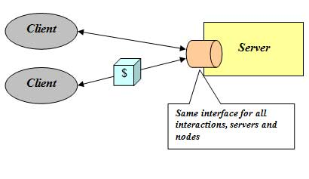
Fig No 6. Uniform Interface
By applying uniform interface constraint:
- Overall system architecture is simplified and the visibility of interactions is improved.

- Implementations are decoupled from the services they provide and encourage independent evaluability.
- Trade off: Degrades efficiency since information is transferred in a standardized form rather than one which is specific to application's needs.
Further a uniform interface has four sub-constraints
- Identification of resources.
- Manipulation of resources through representations
- Self-descriptive messages
- Hypermedia as the engine of application state (HATEOAS)

Client-Server
This is a major constraint and it simply requires the existence of a client component that sends requests and a server component that receives requests. After receiving a request the

server may also issue a response to the client. This constraint is based on the principle of Separation of concerns.
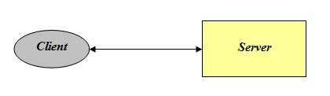
Figure No 7. Separation of concerns

Applying separation of concerns: Client-Server as in the diagram above:
- Separates user interface concerns from data storage concerns.
- Improves portability of interface across multiple platforms.
- Improves scalability by simplifying server components.
- Allows the components to evolve independently.

Stateless Server
The notion of statelessness is defined from the perspective of the server. The constraint says that the server should not remember the state of the application. As a consequence, the client should send all information necessary for execution along with each request, because the server cannot reuse information from previous requests as it didn’t memorize them. All info needed is in message.
By applying statelessness constraint:
- Session state is kept entirely on the client.
- Visibility is improved since a monitoring system does not have to look beyond a single request.
- Reliability is improved due to easier recoverability from partial failures.
- Scalability is improved due to not having to allocate resources for storing state
- Server does not have to manage resource usage across requests.
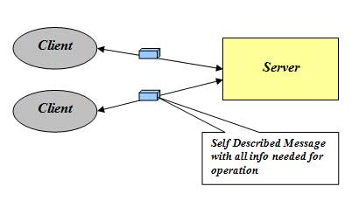
Figure No 8. Stateless
Stateless constraint has following tradeoffs:
- Reduced Network Performance
- Reduced server control over application consistency

Cacheable
REST includes cache constraints so that the "second fetch" doesn't have to be made at all if the data is already sitting in your local cache (or can be a request that only uses partial network resources if the cache is an intermediary or server-side). If your data can be designed in such a way to take advantage of this, you can reduce total network traffic by orders of magnitude.
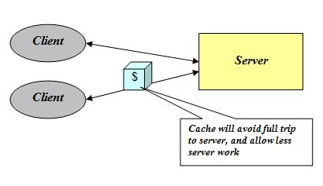 Figure No 9. Cacheable

By adding optional non-shared caching:
- Data within a response to a request is implicitly or explicitly labeled as cacheable or non-cacheable.
- If a response is cacheable, then a client cache is given the right to reuse that response data for later, equivalent requests.
- Improves efficiency, scalability and user perceived performance.
- Tradeoff: cacheable constraint reduces Reliability.

Layered System
There are many layers between the client and the server. These are called intermediaries and can be added at various points in the request-response path without changing the interfaces between components, where they do things to passing messages such as translation or improving performance with caching. Intermediaries include proxies and gateways.
Proxies are chosen by the client, while gateways are chosen by the origin server or are imposed by the network.
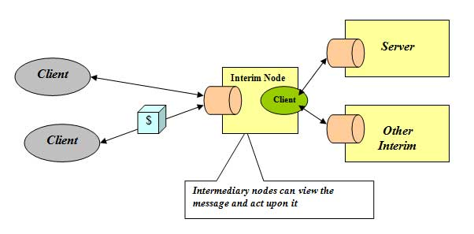
Figure No 10. Layered System

By applying a layered system constraint:
- Similar to client-server constraint this constraint improves simplicity by separating concerns.
- Can be used to encapsulate legacy services or protect new services from legacy clients.
- Intermediaries can be used to improve system scalability by enabling load balancing
- Placing shared caches at boundaries of organizational domain can result in significant benefits. Can also enforce security policies e.g. firewall.
- Intermediaries can actively transform message content since messages are self-descriptive and their semantics are visible to the intermediaries
- Trade off: Adds overhead and latency and reduce user perceived performance.

Code on Demand
Code on demand is an optional constraint. It allows a client to download and execute code from a server.
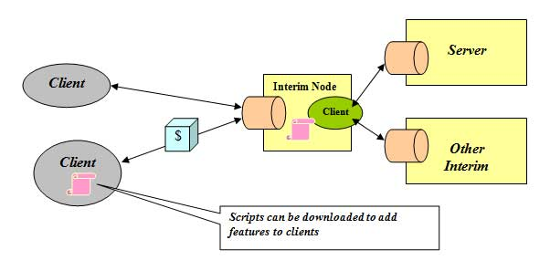
Figure No 11. Code on demand
By applying Code on demand constraint:
- Simplifies clients, hence promotes the reduced coupling of features.
- Improves scalability by virtue of the server off-loading work onto the clients.
- Trade off: Reduces visibility generated by the code itself, which is hard for an intermediary to interpret.

How RESTful APIs work
A RESTful API breaks down a transaction to create a series of small modules. Each module addresses a particular underlying part of the transaction. This modularity provides developers with a lot of flexibility, but it can be challenging for developers to design from scratch. Currently, the models provided by Amazon Simple Storage Service, Cloud Data Management Interface and OpenStack Swift are the most popular.
A RESTful API explicitly takes advantage of HTTP methodologies defined by the RFC 2616 protocol. They use GET to retrieve a resource; PUT to change the state of or update a resource, which can be an object, file or block; POST to create that resource; and DELETE to remove it.
With REST, networked components are a resource you request access to -- a box whose implementation details are unclear. The presumption is that all calls are stateless; nothing can be retained by the RESTful service between executions.
Because the calls are stateless, REST is useful in cloud applications. Stateless components can be freely redeployed if something fails, and they can scale to accommodate load changes. This is because any request can be directed to any instance of a component; there can be nothing saved that has to be remembered by the next transaction.

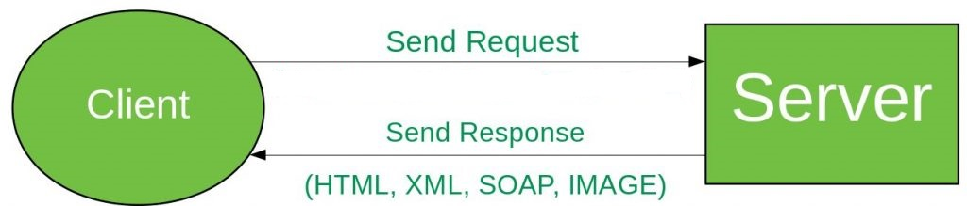
Fig No 12. Working of REST API

REST VS SOAP
One of the major benefits of SOAP is that you have a WSDL service description. You can pretty much discover the service automatically and generate a useable client proxy from that service description (generate the service calls, the necessary data types for the methods and so forth). Note that with version 2.0, WSDL supports all HTTP verbs and can be used to document RESTful services as well, but there is a less verbose alternative in WADL (Web Application Description Language) for that purpose.
With RESTful services, message security is provided by the transport protocol (HTTPS), and is point-to-point only. It doesn’t have a standard messaging system and expects clients to deal with communication failures by retrying. SOAP has successful/retry logic built in and provides end-to-end reliability even through SOAP intermediaries.
One of the major benefits of RESTful API is that it is flexible for data representation, for example you could serialize your data in either XML or JSON format. RESTful APIs are cleaner or easier to understand because they add an element of using standardized URIs and gives importance to HTTP verb used (i.e. GET, POST, PUT and DELETE).
RESTful services are also lightweight, that is they don’t have a lot of extra xml markup. To invoke RESTful API all you need is a browser or HTTP stack and pretty much every device or machine connected to a network has that.

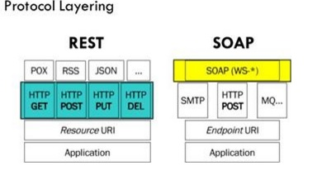
Fig No 13. REST VS SOAP

Optimistic locking
If you choose to implement a concurrency control strategy, optimistic locking is likely to be the best bet. Optimistic locking works like the following: try to do an operation, then fail if the resource has changed since last seen. Optimistic locking is opposed to pessimistic locking where a resource is locked from alteration before any changes are done, then released. As pessimistic locking schemes require state to be kept at the server it does not play well in RESTful APIs where it is idiomatic to keep the server stateless.
The general approach for optimistic locking is to along with your payload send a value that identifies which version of the resource you are modifying. If the version to modify from is stale, the request should fail. The version identifier could be an explicit version number or hash of the unmodified resource. Last modified timestamps could also be used, but with caution as clocks might be skewed in a distributed environment.
Identifying the version in a HTTP request one can either put the version identification as part of the request model in the payload or utilize the if match request-header from the HTTP/1.1 specification. Note that the HTTP/1.1 specification requires 412 (Precondition failed) to be returned upon conflict.
As a mechanism of concurrency control optimistic locking is a simple yet powerful approach. Implementing it for the api-creator is relatively straightforward. This approach does however impose the risk of end-user’s suffering. A stricter concurrency control strategy requires that the entire end-to-end flow adhere to it. The integrator would be forced to implement graceful resolving of conflicts due to the concurrency control — likely a non-trivial task, definitely so if a GUI is involved.

Tools & Frameworks Used
The various tools and frameworks used in our projects are
- Visual Studio Code
- Angular
- Node JS
- Python
- Flask

Visual Studio Code
Visual Studio Code is a source-code editor developed by Microsoft for Windows, Linux and macOS. It includes support for debugging, embedded Git control, syntax highlighting, intelligent code completion, snippets, and code refactoring. It is also customizable, so users can change the editor's theme, keyboard shortcuts, and preferences. The source code is free and open source and released under the permissive MIT License. The compiled binaries are freeware and free for private or commercial use.
Visual Studio Code is a lightweight but powerful source code editor which runs on your desktop and is available for Windows, macOS and Linux. It comes with built-in support for JavaScript, TypeScript and Node.js and has a rich ecosystem of extensions for other languages (such as C++, C#, Java, Python, PHP, Go) and runtimes (such as .NET and Unity).

Visual Studio Code in action
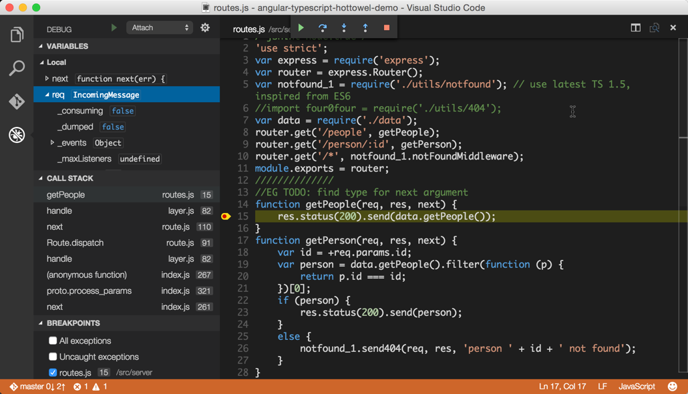
Fig No 14. Visual Studio Code running

Angular
Angular is a platform that makes it easy to build applications with the web. Angular combines declarative templates, dependency injection, end to end tooling, and integrated best practices to solve development challenges. Angular empowers developers to build applications that live on the web, mobile, or the desktop.

Advantages of Angular
There are various advantages of Angular

3.2.1.1 Cross Platform
- Progressive Web Apps – Use modern web platform capabilities to deliver app-like experiences. High performance, offline and zero-step installation.
- Desktop – Create desktop- installed apps across Mac, Windows and Linux using

the same Angular methods we’ve learned for the web plus the ability to access native OS APIs.
- Native – Build native mobile apps with strategies from Ionic or NativeScript.

Speed and Performance
- Code Generation – Angular turn our templates into code that’s highly optimized for today’s JavaScript virtual machines, giving us all the benefits of hand written code with the productivity of a framework.
- Code Splitting – Angular apps load quickly with the new Component Router, which delivers automatic code-splitting so users only code required to render the view they request.

Productivity
- Templates – Quickly create UI views with simple and powerful template syntax.
- IDEs – Get intelligent code completion, instant errors, and other feedback in popular editors and IDEs.
- Angular CLI Command line tools start building fast, add components fast add components and tests, then instantly deploy.

Full Development
- Testing - With Karma for unit’s tests, we can know if we’ve broken things every time we save. And Protractor makes our scenario tests run faster and in a stable manner.
To use Angular, we have used Typescript, HTML, CSS and various services

Installation of Angular
To install Angular we first installed Node.JS
Node.js Installation -
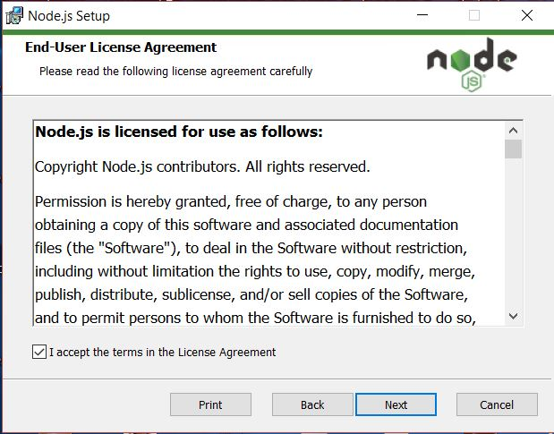
Fig No 15. Python Installation

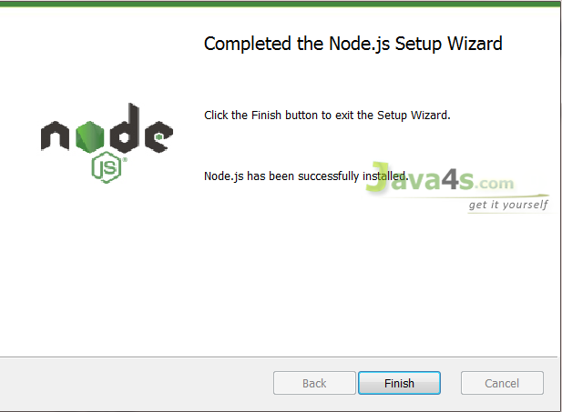
Fig No 16. Python Installation(contd)
Now after installing we installed angular through node.js command prompt with following command-
npm install –g @angular/cli
This command installed the latest version angular on our pc thorough node.js and then through the command ng -v
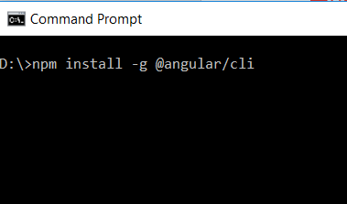
Fig No 17. Angular Installation
To create a new project, the command we typed was
ng new project-name
This command will create a new project with the name given add all the possible files needed to build the project
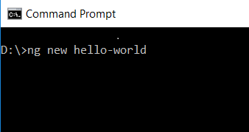
Fig No 18. Creating new Project in Angular

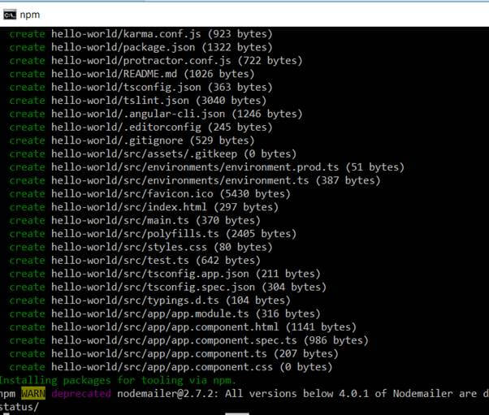
Fig No 19. Creating new Project in Angular(contd)

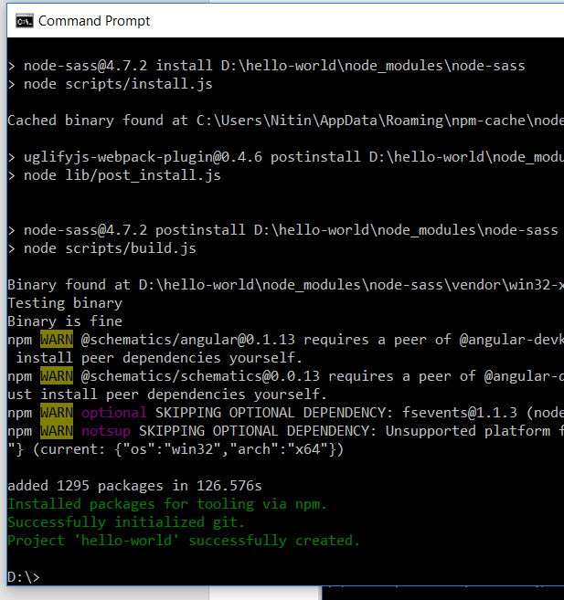
Fig No 20. Creating new Project in Angular(contd)

In above the angular is installed and a new project is created.

TypeScript
TypeScript lets us write JavaScript the way we really want to. TypeScript is a typed superset of JavaScript that compiles to plain JavaScript. TypeScript is pure object oriented with classes, interfaces and statically typed like C# or Java. The popular JavaScript framework Angular 2.0 is written in TypeScript. Mastering TypeScript can help programmers to write object-oriented programs and have them compiled to JavaScript, both on server side and client side.

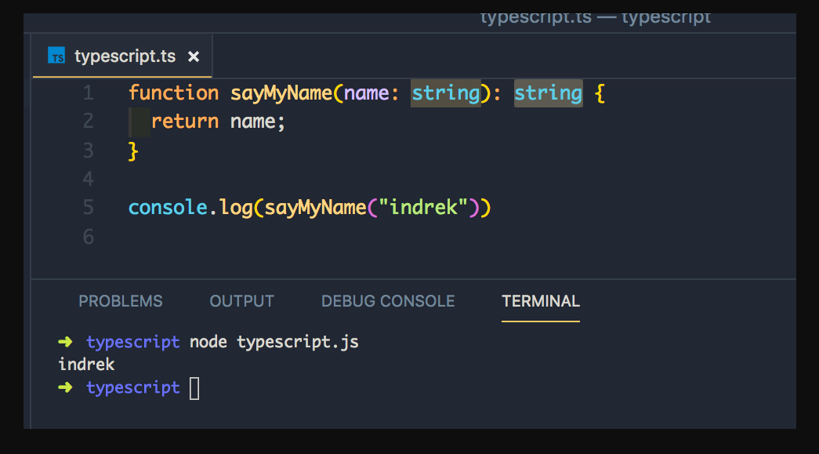
Fig No 21. TypeScript Example

ECMA Script
ECMAScript (or ES) is a scripting-language specification standardized by Ecma International in ECMA-262 and ISO/IEC 16262. It was created to standardize JavaScript, so as to foster multiple independent implementations. JavaScript has remained the best-known implementation of ECMAScript since the standard was first published, with other well-known implementations including JScript and ActionScript. ECMAScript is commonly used for client-side scripting on the World Wide Web, and it is increasingly being used for writing server applications and services using Node.js.
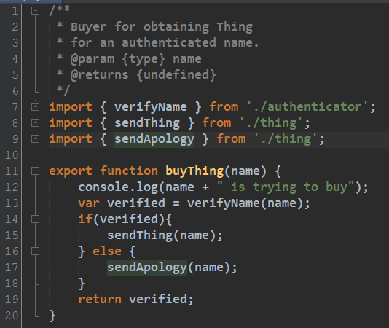
Fig No 22. ECMA Script Example

Python
Python is a high-level, interpreted, interactive and object-oriented scripting language. Python is designed to be highly readable. It uses English keywords frequently where as other languages use punctuation, and it has fewer syntactical constructions than other languages.
- Python is Interpreted − Python is processed at runtime by the interpreter. You do not need to compile your program before executing it. This is similar to PERL and PHP.
- Python is Interactive − You can actually sit at a Python prompt and interact with the interpreter directly to write your programs.
- Python is Object-Oriented − Python supports Object-Oriented style or technique of programming that encapsulates code within objects.

- Python is a Beginner's Language − Python is a great language for the beginner-level programmers and supports the development of a wide range of applications from simple text processing to WWW browsers to games.

Python Features
Python's features include −
- Easy-to-learn − Python has few keywords, simple structure, and a clearly defined syntax. This allows the student to pick up the language quickly.
- Easy-to-read − Python code is more clearly defined and visible to the eyes.
- Easy-to-maintain − Python's source code is fairly easy-to-maintain.
- A broad standard library − Python's bulk of the library is very portable and cross-platform compatible on UNIX, Windows, and Macintosh.
- Interactive Mode − Python has support for an interactive mode which allows interactive testing and debugging of snippets of code.
- Portable − Python can run on a wide variety of hardware platforms and has the same interface on all platforms.
- Extendable − You can add low-level modules to the Python interpreter. These modules enable programmers to add to or customize their tools to be more efficient.
- Databases − Python provides interfaces to all major commercial databases.
- GUI Programming − Python supports GUI applications that can be created and ported to many system calls, libraries and windows systems, such as Windows MFC, Macintosh, and the X Window system of Unix.
- Scalable − Python provides a better structure and support for large programs than shell scripting.

Python Installation
- First install the Python application from python website then double click on the icon labelling python-3.7.0.exe.
- Click Run.
A Python 3.7.0 (32-bit) Setup pop-up window will appear.

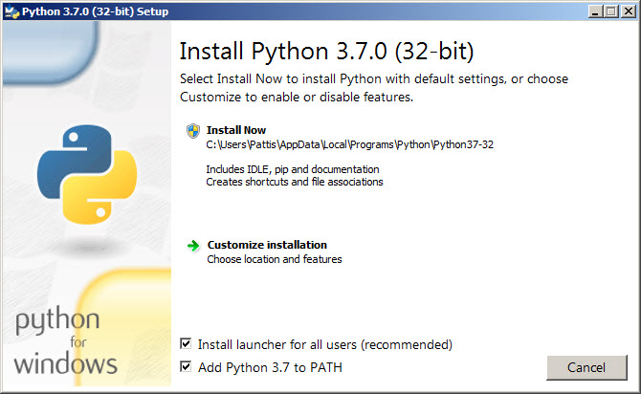
Fig No 23. Python Installation
A new Python 3.7.0 (32-bit) Setup pop-up window will appear with a Setup Progress message and a progress bar
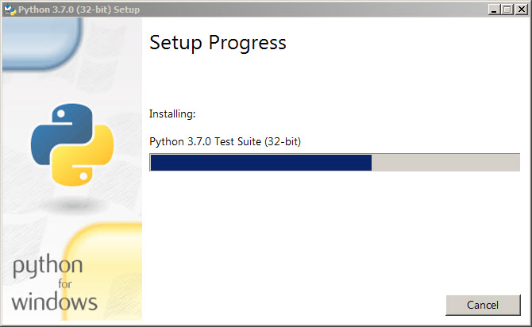
Fig No 24. Python Installation(contd)

During installation, it will show the various components it is installing and move the progress bar towards completion. Soon, a new Python 3.7.0 (32-bit) Setup pop-up window will appear with a Setup was successfully message.
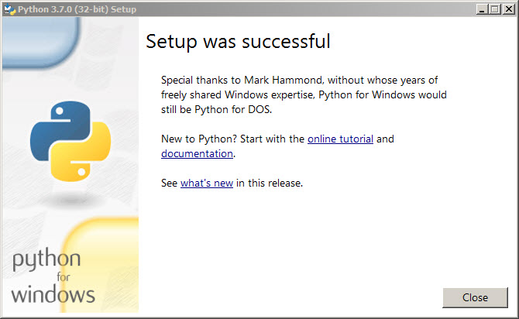
Fig No 25. Python Installation(contd)

Flask
After installing Python, we installed flask which we are using for our server part which will be handling logic and the request
Flask is a micro web framework written in Python. It is classified as a micro framework because it does not require particular tools or libraries.^{[3]} It has no database abstraction layer, form validation, or any other components where pre-existing third-party libraries provide common functions. However, Flask supports extensions that can add application features as if they were implemented in Flask itself. Extensions exist for object-relational mappers, form validation, upload handling, various open authentication technologies and several common framework related tools. Extensions are updated far more regularly than the core Flask program.
Flask is considered more Pythonic than the Django web framework because in common situations the equivalent Flask web application is more explicit. Flask is also easy to get started with as a beginner because there is little boilerplate code for getting a simple app up and running.
To install flask in python the command used is pip3 install flask

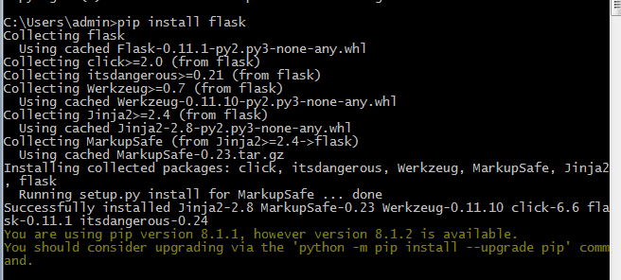
Fig No 26. Python Installation(contd)

Implementation

Creating Server
First we created the server for implementing the logic for the APIs by using the flask web framework in Python.
For this we have used the various HTTP methods like GET, POST, PUT, DELETE.

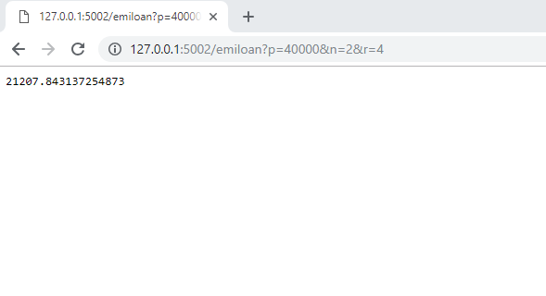
Fig No 27. Accessing EMI Calculator API through URL

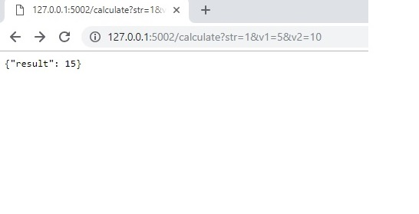
Fig No 28. Accessing Calculator API through URL

Creating Client Side
- Then we developed a new project in Angular which we are using as Client. Through Angular the user is requesting the server for accessing the various RESTFul APIs which are available through that URL.
- We added components for each API we created at the server end and every component is calling the APIs available at the server side through the URL, the logic of which we have implemented in the TypeScript file of each component.
- For all the components we will create a common service to keep the track API calls from the user as well the time taken by each user call to process the request.
- This will help us to find the performance of all the APIs.
- Below we have added some screenshots of our ongoing project through which we have explained what is actually happening in our project.

Our Main Page looks like below picture -

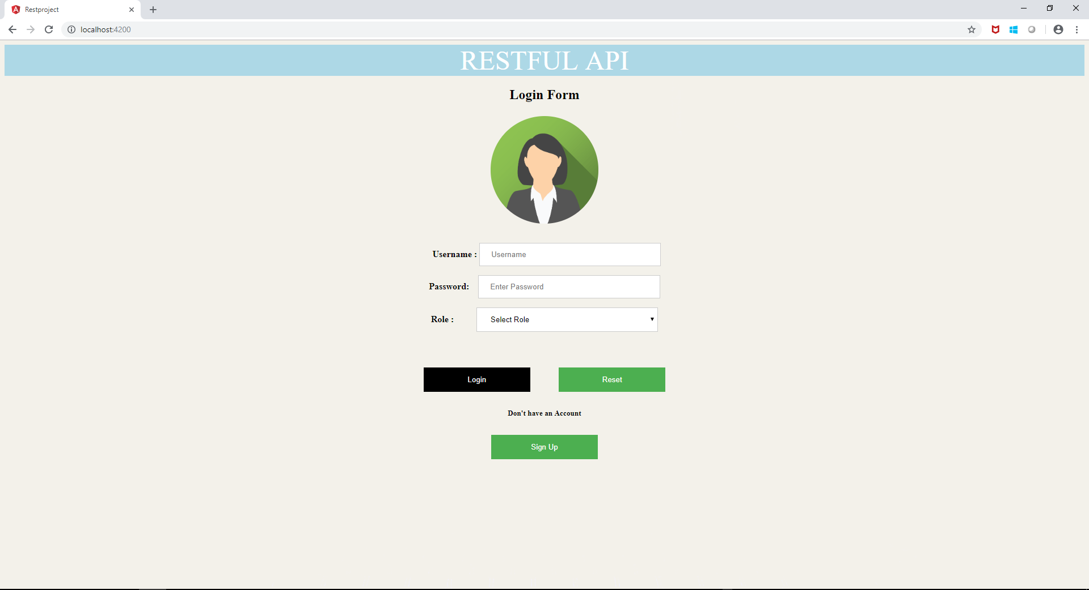
Fig No 29. Home Page of our Application

- Here there are two options available for login that is for the user and admin.
- If the person is the user, then he can access the various APIs available.
- If the person is the admin then he can view the usage and performance of all the APIs .
- Now next is the user Home Page from where he can access the provided RESTFul APIs which are available as URLs.
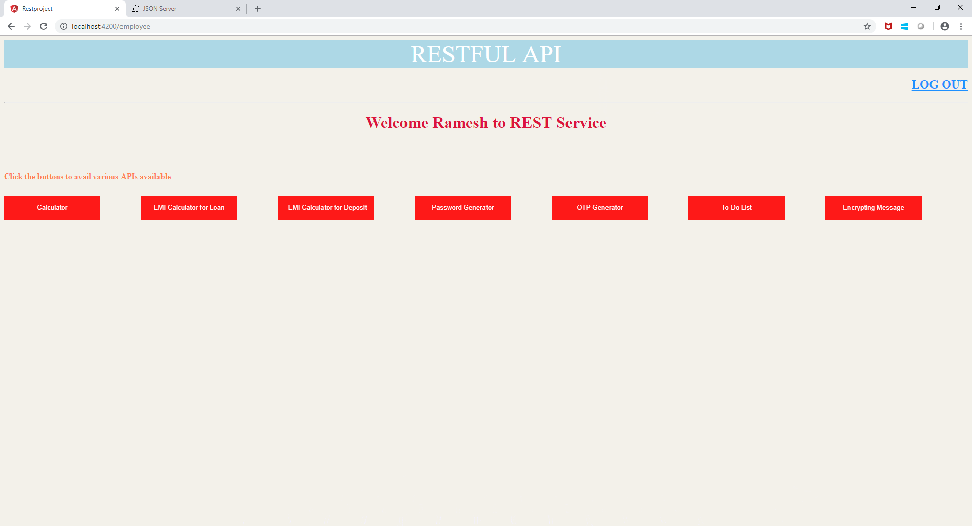
Fig No 30. Home Page of the User

To access any API the user will click on any of the options available, of which he want to access the API.
After clicking on any of the options the user will be directed to that component to avail that API by entering the inputs which may be different for the APIs in the GUI part.

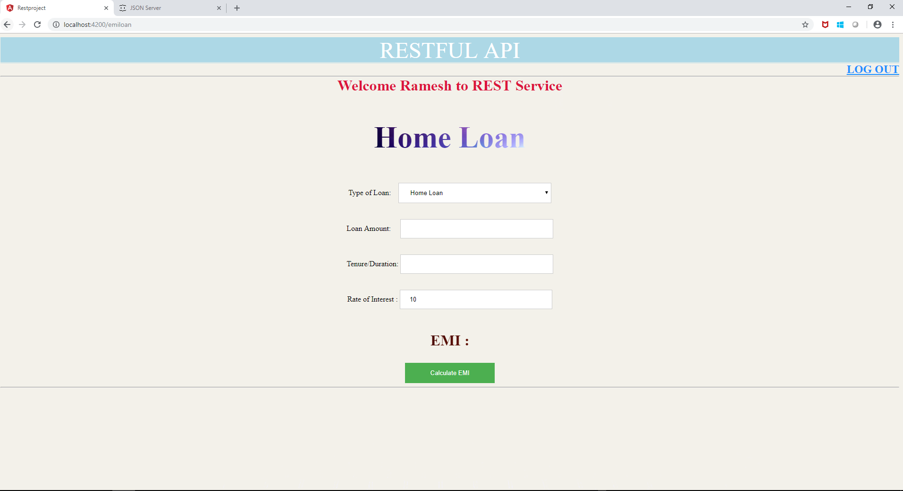

Fig No 31. API component for EMI calculation

In the above part the user will be entering the inputs, and after entering the inputs, as the user will be clicking on the calculate EMI button the values entered will internally be passed to the server through the URL and the logic for that particular Emi will be executed by taking those values as input .
After calculating the result that result will be sent back as json which we will be received at the client side.
Then that json format is converted and stored in a variable which is displayed on the screen as result

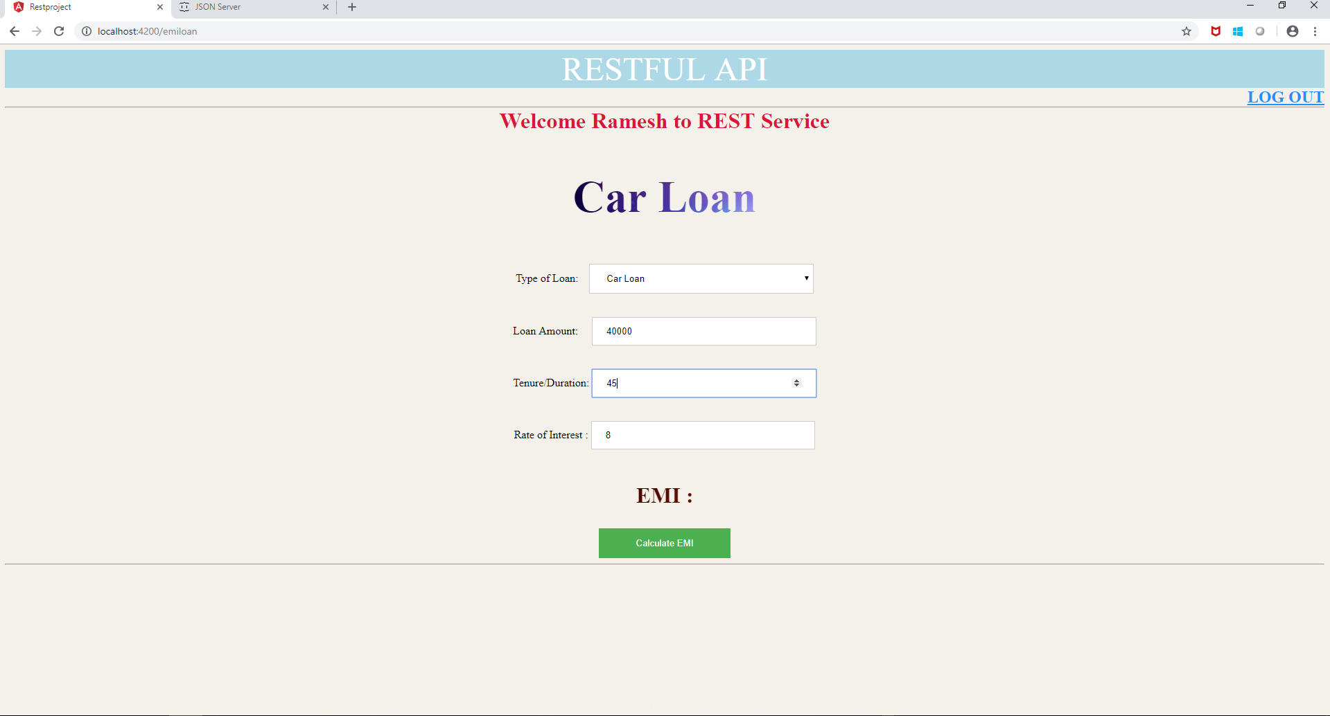

Fig No 32. Entering the inputs

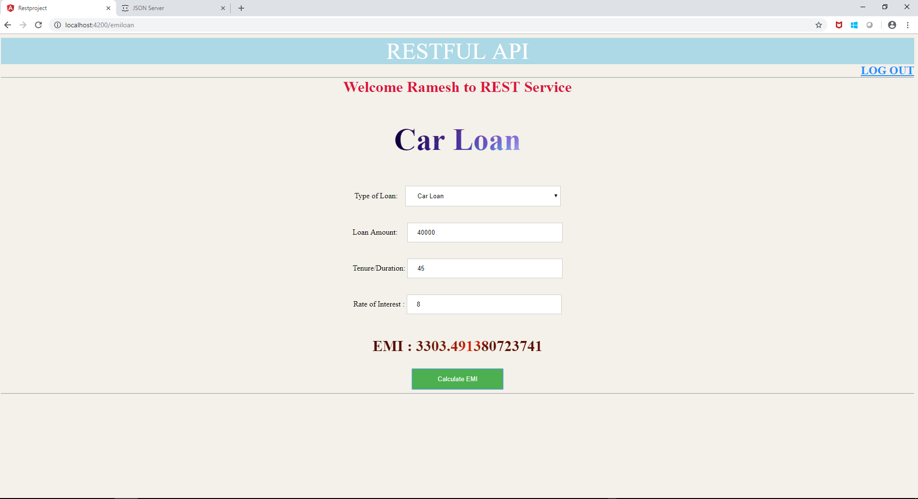
Fig No 33. Received Result

The result which is displayed is through the API running at the server side

Another API calculator Screen Shots

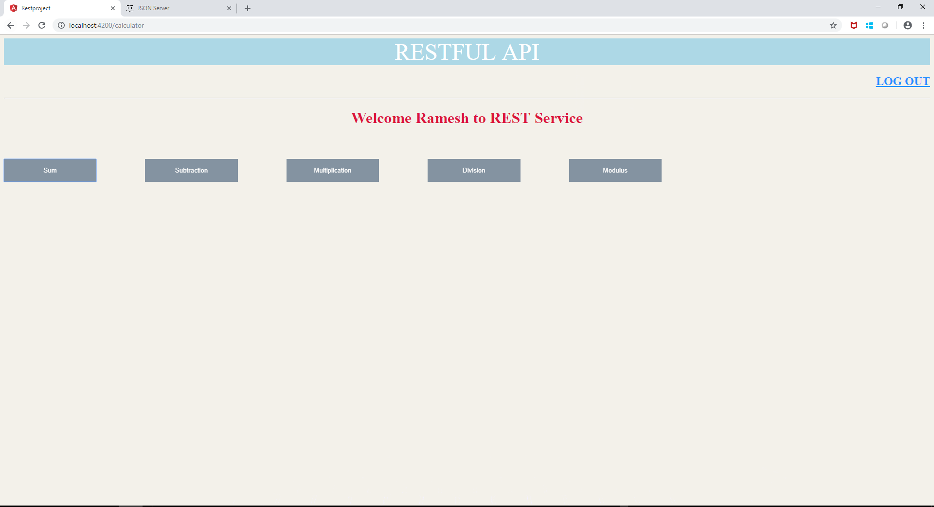

Fig No 34. More APIs

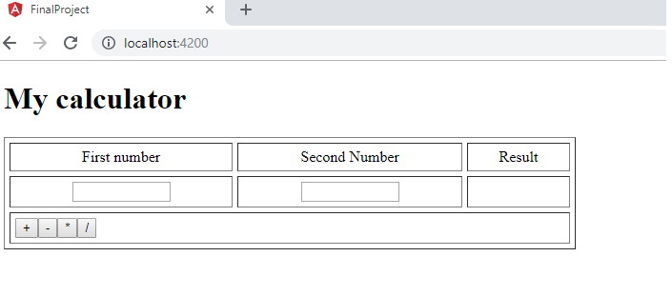
Fig No 35. More APIs(contd)

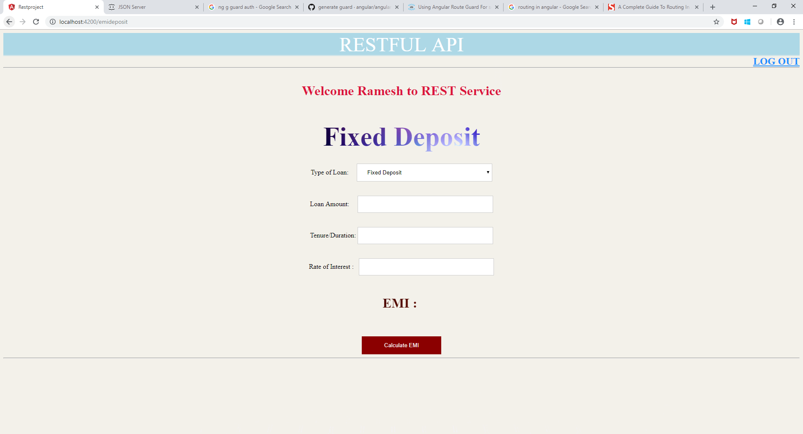

Fig No 36. Received Result (contd)

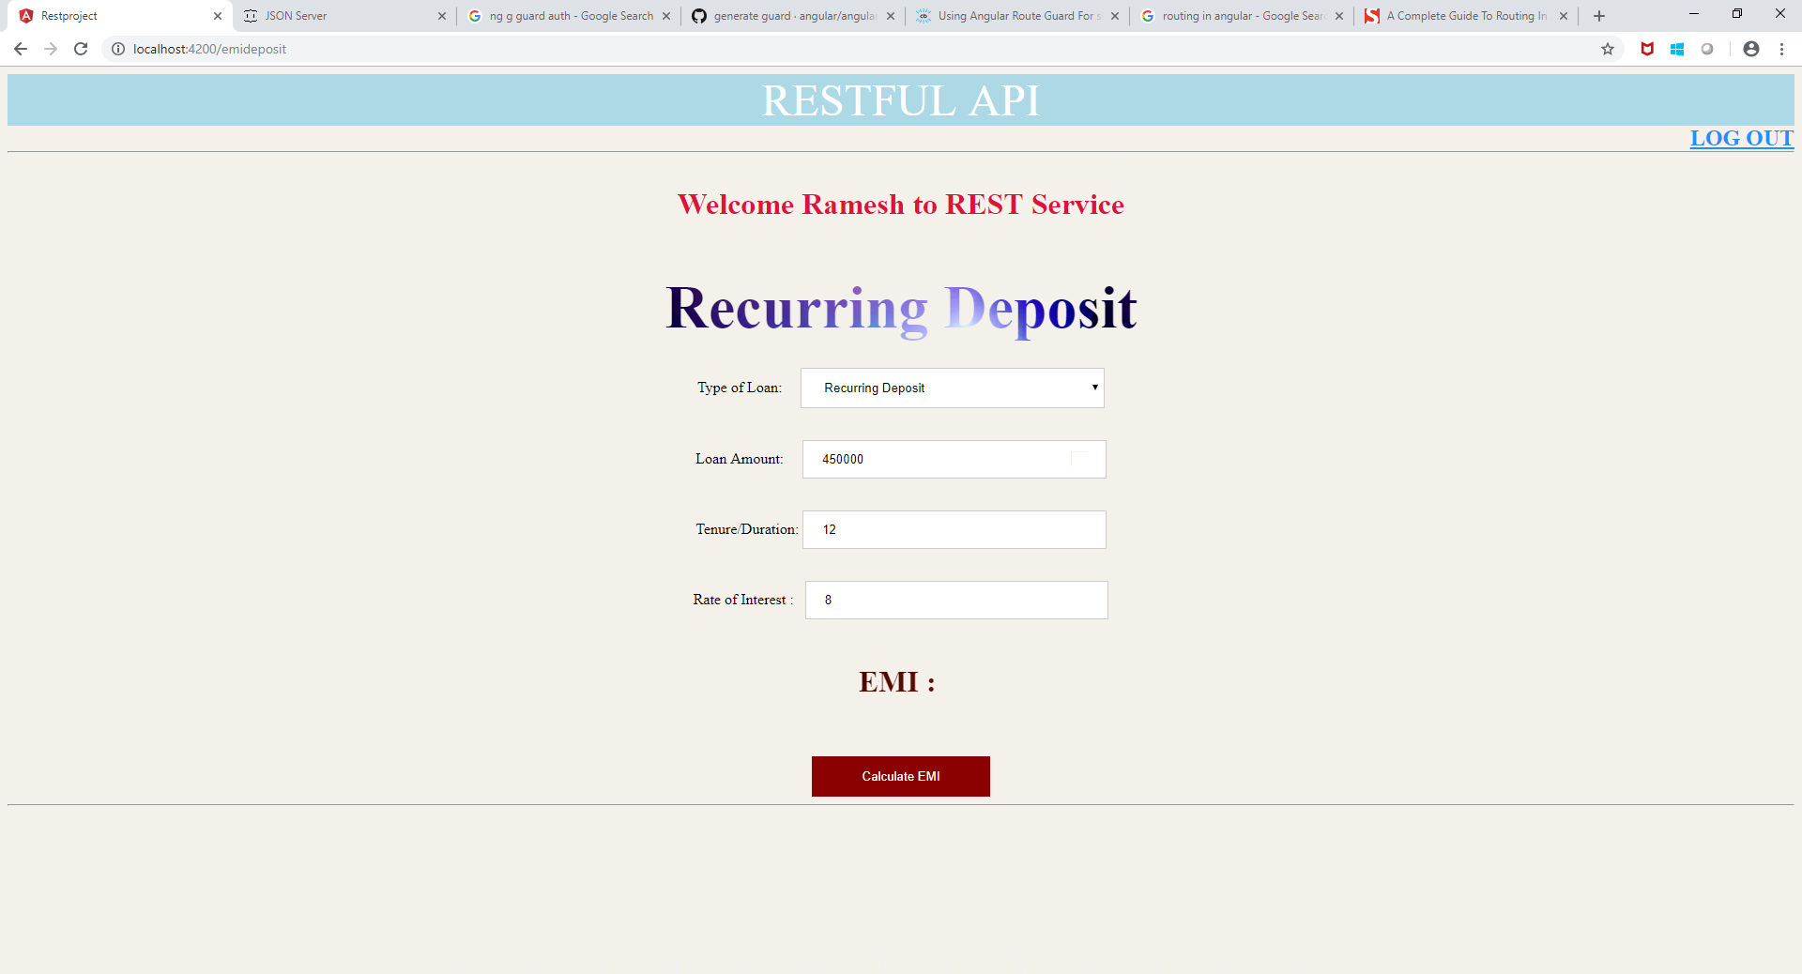

Fig No 37. Received Result(contd)

For security we have added the guard auth service so that the user is not able to access the api with authentication and cannot modify it.

To use it we have use the command ng g guard auth and by default made it canActivate
For routing purpose we have used the routing service so that the components can be accessed easily and in a secure manner .
For database we have used the json-server for storing the data of the user , and below the json data

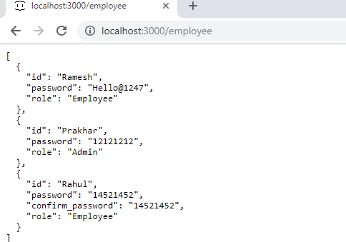

Fig No 38. JSON DATA

